Genetics and Evolution Terminology
Chromosome
gene
Pedigree
heterozygous
Sex – l inked
gametes
Mutat ion
Dom inant
A l lele
P e n o t y p
M I o s I s
H o m o z y g u s
R c e s s I v
N a t u a l c i o
E v o l t I o
G e n o t p e
D

A
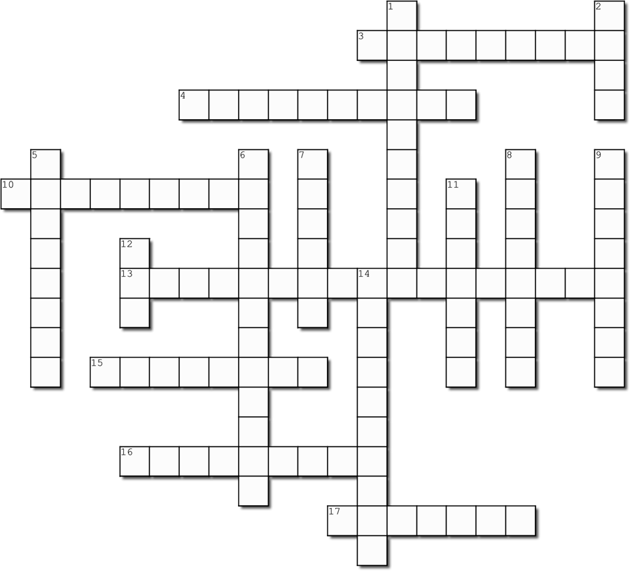

Across
- The description of what the genotype means, eg:
black hair, tongue roller
- Having both the same type of allele for a trait, ie: either both dominant, or both recessive
10. The characteristic that is masked by a dominant allele
13. The process in which organisms that are best adapted to an environment survive and reproduce more than others
15. The letters that show what alleles an organism has, eg: BB or Bb or bb
16. The gradual development of different species from a common ancestor
17. Cell division in sex cells

Down
1. Long, thread-like structures found in the nucleus, made up of genes
- A portion of a chromosome that codes for a particular characteristic or trait
- ‘Family Tree’ which shows genetic information about how characteristics have been passed on through generations
- Having two different alleles - one dominant and one recessive allele for a trait (‘mixed’)
- A version of a gene
- A change or abnormality in a gene or chromosome
9. The gene which determines the outcome, represented by a capital letter, it is always expressed in the phenotype
11. Sex cells (sperm and eggs)
12. Molecule that carries the genetic code or blueprint for making the organism
14. When the gene is carried on the X chromosome

GENETICS AND EVOLUTION REVISION

- The following questions are about DNA:
- What is its function? DNA contains the blueprint for a living organism. It is made up of bases in a particular order which determines the proteins that cells make, and thru this process controls the entire structure and functions of a living organism.
- What is its shape called? Double helix
- Where is it found? In the nucleus of cells
- What is it made up of? The outside of the double helix is a sugar phosphate continuos chain of molecules, and the base units adenosine, thymine, guanosine, and cytosine bond across between the outer strands, much like the rungs on a twisted ladder.

- Write down the partner DNA strand for this one:
CTAAGCACCGTCGACTTACGTA GATTCGTGGCAGCTGCTGAATGCAT

- What is a chromosome? How many do humans usually have in their cells? A chromosome is a very long strand of DNA. There are 46 chromosomes in each human cell

- The following questions are about sex cells:
- What is another name for sex cells? Gametes
- What are the sex cells called in males and in females? Males – sperm; and females - ovum
- How many chromosomes do sex cells have? Explain why. Sex cells or gametes have only 23 chromosomes. This is because the male and female gametes must combine to form a new human – so each gamete has 23 to make the full complement of 46 chromosomes

- Explain how males are responsible for determining the sex of the offspring. The sex of a person is determined by the 23rd pair of chromosomes that they have. Females have two X chromosomes (XX), while males have an X and a Y (XY). Thus the female mother has to pass an X chromosome to her ovum, but the male may pass an X onto some sperm, but also pass a Y onto other sperm (50% split). If the ovum is fertilised by a sperm with a Y, then the fertilized ovum will be XY and be male. If the ovum is fertilised by a sperm with an X, then the fertilized ovum will be XX and be female.

- Draw a punnet square for a cross between a plant with red flowers (Rr) and a plant with white flowers (r
 |  | t |  | t
T | Tt |  | Tt
t | tt |  | tt

T
tt
Tt
 |  | R |  | r
r | Rr |  | rr
r | Rr |  | rr

- In anemones, the gene for having stinging tentacles is dominant over non-stinging tentacles. Work out the predicted genotypes and phenotypes of the offspring produced if a homozygous non-stinging anemone is crossed with a heterozygous stinging anemone.

Genotypes: 50% Tt, 50% tt
Phenotypes: 50% stinging tentacles (have a dominant allele), 50% non-stinging.

 |  | L |  | L
l | Ll |  | Ll
l | Ll |  | Ll

L
ll
LL
- Long hair in dogs is dominant over short hair. Work out the genotypes and phenotypes of the offspring produced by a homozygous long haired dog and a short haired dog.

Genotypes: 100% LI
Phenotypes: 100% long hair
- Large wing span is dominant over short wing span in owls. Calculate the percentage of offspring that would be expected to have a large wing span as a result of a cross between two heterozygous wing span owls.
 |  | W |  | w
W | WW |  | Ww
w | Ww |  | ww

W
Ww and Ww

75% would have a large wing span (75% have the dominant large wing allele)

- A brown mouse is crossed with a white mouse. All of the offspring are brown. What does this suggest about the gene for brown colouring?
This suggests that the allele for brown colouring is dominant over the allele for white colouring. The more offspring there were the more likely this is true.
 |  | X_{b} | Y
X_{B} | X_{B}X_{b} |  |  | X_{B}Y
X_{b} | X_{b}X_{b} |  |  | X_{b}Y

X_{b}
X_{b}Y
X_{B}X_{b}
- Being colour blind in humans is a sex-linked recessive trait. What are the possible genotypes and phenotypes for the offspring of a colour blind male and a carrier female?

Male (XY) Genotype: 50% X_{B}Y, 50% X_{b}Y
Phenotype: 50% normal vision, 50% colour blind
Female (XX) Genotype: 50% X_{B}X_{b}, 50% X_{b}X_{b}
Phenotype: 50% normal vision, 50% colour blind

 |  | X_{D} | Y
X_{d} | X_{D}X_{b} |  |  | X_{d}Y
X_{d} | X_{D}X_{b} |  |  | X_{d}Y

X_{d}
X_{D}Y
X_{d}X_{d}
- The gene for Schmuck’s disease is recessive and carried on the X chromosome. If a mother who has the disease has children with a father that doesn’t have the disease, what possible genotypes and phenotypes are there for their children?

Male (XY) Genotype: 100% X_{d}Y
Phenotype: 100% have Schmuck’s disease
Female (XX) Genotype: 100% X_{D}X_{d}
Phenotype: 100% do not have disease

- Explain what a mutation is. List the different causes of mutations and the differences and consequences of a germline mutation versus a somatic mutation.
A mutation is an alteration or change in the sequence of bases within DNA. Mutations are more dangerous if they occur in a gene (and not the “junk” DNA).
Causes of mutation include
- errors in copying the DNA during the formation of sperm and ovum
- Ultra-violet radiation in sunlight
- Radioactivity
- Some chemicals such as those found in tobacco products.
A germline mutation is one carried in the sperm or ovum, so the person has the mutation from the very start of their life, and the mutation is in every cell of their body. These mutations are passed on thru generations. A somatic mutation is one htat has occurred during the life of a person. It causes changes in the affected cells and are responsible for cancers and tumours, but are not passed on thru inheritance.

- The pedigree chart below shows how Cystic Fibrosis, an autosomal recessive disease, can be traced through three generations.
- Not sex-linked, so no need for XX and XY.
- Recessive, so affected people are aa

- Write the genotypes of the individuals on the lines next to each one.

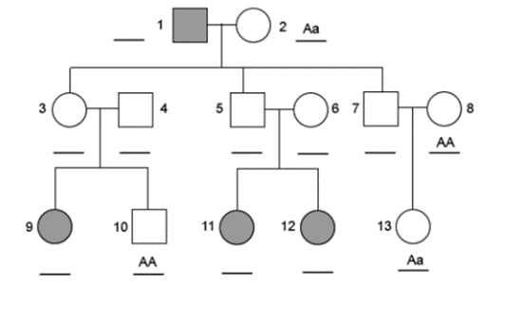
aa
aa
aa
aa
Aa
Aa
Aa
Aa
Aa
- What is the phenotype and sex of
- Individual 3 3 has a dominant allele so does NOT have cystic fibrosis, is a female
- Individual 5 5 has a dominant allele so does NOT have cystic fibrosis, is a male
- Individual 12 12 is homozygous recessive so has cystic fibrosis, is a female

- How many grandsons does individual 2 have? 5

- The following questions are about Evolution:
- Define Evolution
- Explain the process of Natural Selection
- Outline how each of the following provide evidence for the theory of evolution:
- Fossil record
- Comparative anatomy
- Embryology
- DNA
- Evolution is the gradual change in species over a long period of time (there are lots of ways to define evolution, but they should all discuss change in organisms, and a long time period)

- Natural selection basically states that organisms (offspring) which are more adapted to suit their environment wil be more likely to survive and reproduce, thus passing their traits onto the next generation.

- (i) Paeleontology - Scientists can compare the older fossils of a species (or simila species) with younger fossils. This allows scientists to show how there have been changes in species (evolution) over time.

(ii) Comparative Anatomy - Many animals have body parts that are similar in both structure and function - these are called homologous structures. This suggests that the anatomy of animals is inherited from a common ancestor and evolved over time in different species. Thus the different changes in the forelimbs are adaptations to the needs of the organisms.

(iii) Embryology - The embryos of most vertebrates look very similar and have similar structures. This suggests that all animals have a similar origon or ancient ancestor.

(iv) DNA - Scientists can now look at how similar the DNA is in two separate species. This can show how closely they are related. The less alike organisms are the less similarity in their DNA, suggesting that evolution from a common ancestor occurred a very long time ago, but that very similar species share more recent common ancestors.

